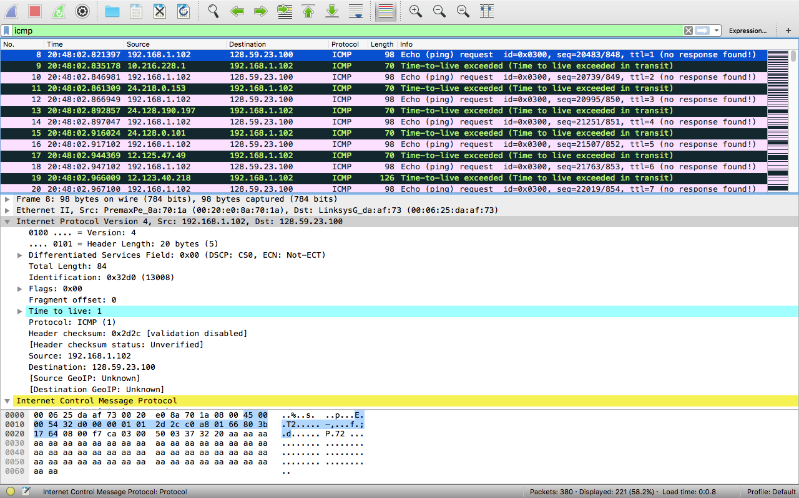

1. 192.168.1.102
2. ICMP (1)
3. Second line says the header is 20 bytes, and it says the total length is 84, so the datagram is 64 bytes
4. The more fragments flag is not set, so no extra fragments

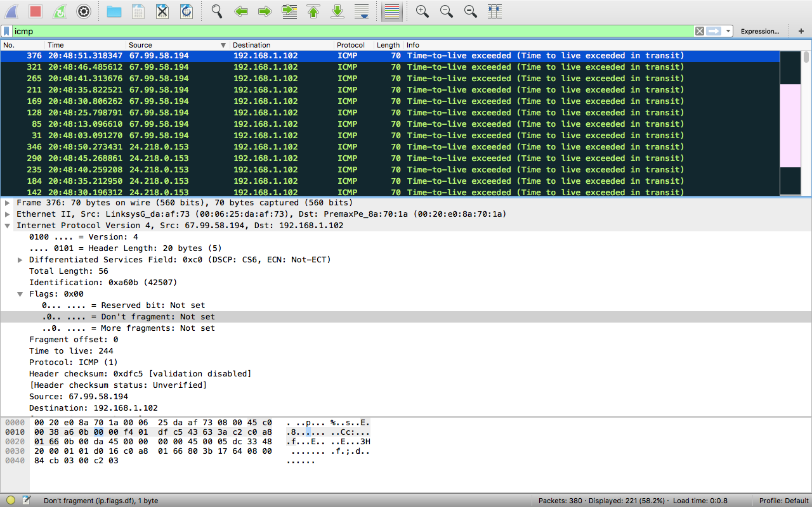

1. The ID, checksum and TTL
2. 1. Constant: (and must be)
      1. version (needs the same version)
      2. header length (won’t work if the headers are different sizes)
      3. source IP (All coming from the same place)
      4. Destination IP (all going to the same place)
      5. Differentiated Source (since all packets are ICMP)
      6. Upper Layer Protocol (again, since they’re all ICMP packets)
   2. Must change:
      1. ID (They have to be different to differentiate them)
      2. TTL (traceroute needs an incrementing TTL)
      3. Checksum (the header changes, so the checksum must)
3. The header increments for every echo

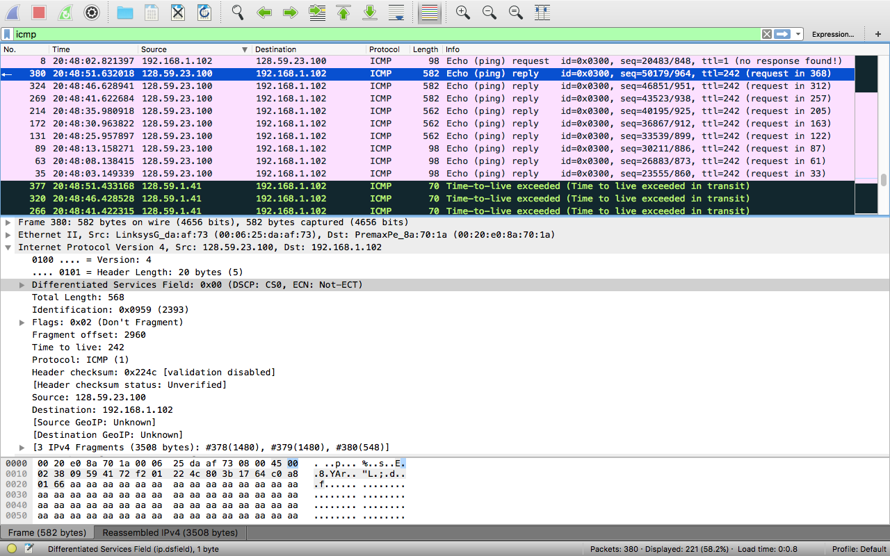

* 1. ID: 2393
  2. TTL: 243

1. ID changes every time because if it stayed the same then it would all be from the same response, the TTL stays the same because it’s all responding from the same router

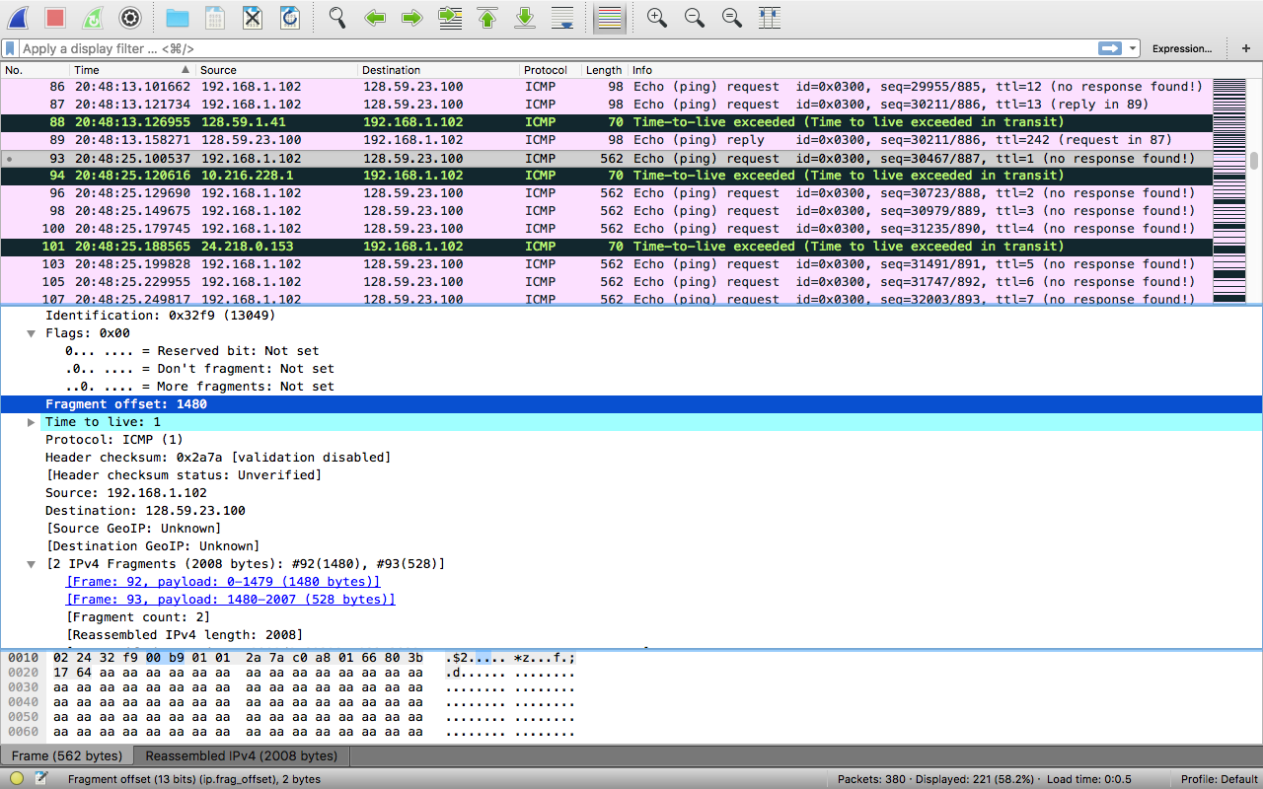

1. Yes
2. The flag for the fragment has been set, I couldn’t find packets 90,91, or 92, so I assume that they were all combined into 93. It’s length is 1480 which is what is expected from a 1500 byte packet with a 20 byte header.
3. Second fragment is the image above. I couldn’t find the first. More fragments is not set and it shows that they’re combined.
4. Like above, I couldn’t find the other pieces, but I know what would change,
   1. The length, flags, fragment offset, and the checksum

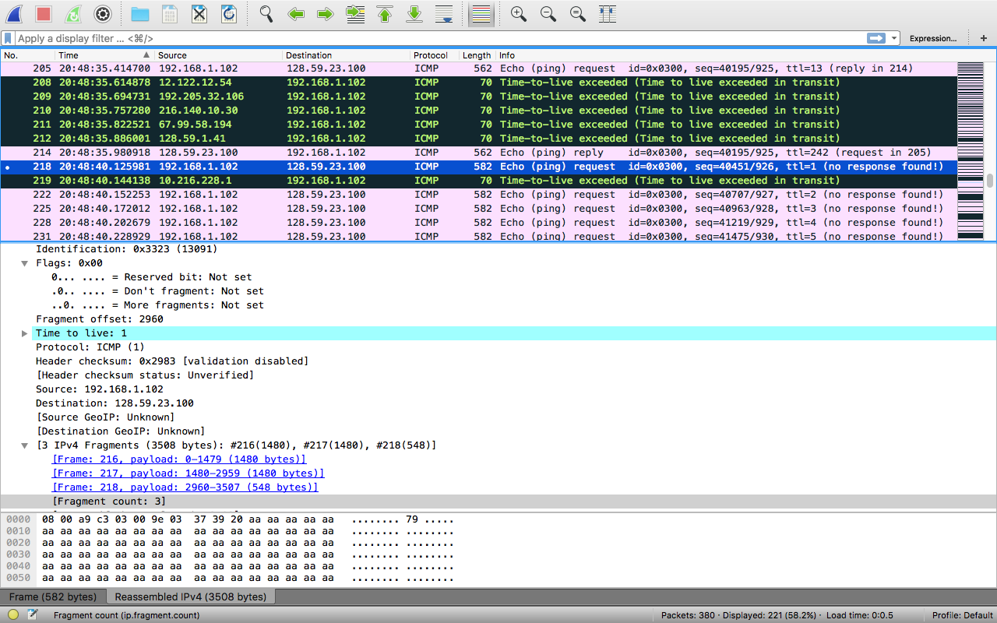

1. 3 fragments
2. Again, I couldn’t see previous packets.
   1. the exact same changes as in 13, except the second and first packets would have the same more fragments flag.